Langchain sites (only for extracting metadata from Audio transcript, eg: Cindy’s Audio):

* <https://python.langchain.com/docs/modules/chains/additional/extraction>
* <https://github.com/rlancemartin/karpathy-gpt>
* We made it work

Link to Slides:<https://docs.google.com/presentation/d/188dg8LnaSzT_xm7sxCTJoDcKnL1xyKXu9j9UKqBPhOA/edit#slide=id.p>

Aim : 1 page summary with names

* 12 ish slides for “poster”

Alternative Plan:

* We got langchain to work so:
  + We are going to compare two popular elearning math video tutorial platforms:
    - Dataset: [LearnLab Summer School Proj Dataset](https://docs.google.com/spreadsheets/d/1DJjC3tme1aSR1Oe_YPoIll7wp0Ss99uguwq5wVIlet8/edit#gid=0)

| Math | Geometry Area | 3 |
| --- | --- | --- |
| Math | Word problems | 2 |
| Math | Solving two-step equations | 3 |
| Chemistry | conversion of units | 2 |

* + Research questions:
    - What makes these videos popular?
    - How do these video platforms differ from one another?
  + What are we using as a comparative measure?
    - Number of likes
    - Number of views
      * Ratio of likes to dislikes
      * Ratio of likes to views
  + Langchain:
    - Find knowledge components in videos
      * We would have to create a metastructure for this
      * What are the KCs?
        + Number of quiz questions
        + Pauses for student/viewer reflection
        + Duration of video
        + Number of worked examples
        + Formulas explained
        + Mention of real life application
        + If any Questions asked to viewers
        + If the question is answered in the video
        + How much time was spent on a knowledge component

The schema:

* Skills covered
* Examples given
* Questions asked

GURU: specific to educational videos

Take a video=> extract the instructors are solving => use that structure to generate new practice questions for the students and have

Extract the questions from a video => give a student those questions and see if they even need to use the video. (if the video has anything new to offer)

Potential Datasets to Use:

* EduNet: <https://www.mdpi.com/1424-8220/21/17/5699>
* Xintian’s collection of standard classroom YouTube videos

1. [*Teaching Observation of Ms. Ainge*](https://www.youtube.com/watch?v=KRgIxK0WNis)*.* Second-grade fractions with 27 students

2. [*Differentiated Instruction in a Secondary Classroom.*](https://www.youtube.com/watch?v=h9P21TBJJ3o)Eighth-Grade Math

3. <https://www.youtube.com/watch?v=YZQFErJn-Eg> First-Grade classroom

5. [4th Grade Science Classroom](https://youtu.be/wg83S9OoX4o)

6. [Kindergarten Language Arts](https://www.youtube.com/watch?app=desktop&v=b6u0EVXYkTU)

7. [Science Elementary](https://www.youtube.com/watch?v=d8_pRUR-hmg&t=2s) (dual language class):

8. [Alan’s Infinity](http://dx.doi.org/doi:10.7282/T39Z93WV) (student led vs. teacher led)

* **We could record ourselves: ex) Datashop (prepare the dataset by tomorrow)**
  + Complete a pre-test on a learning application of some sort
    - Pre-test could consist of a small dataset (i.e. 10 rows) and a couple of questions on the dataset
  + Experience some kind of learning intervention
    - Tutorial of how to use Datashop: Cindy, John
    - Ask someone to record and create pre and post tests
  + Take a post-test (same as the pre-test)
    - Post-test could consist of a small dataset (i.e. 10 rows) and a couple of questions on the dataset
  + Recording plan



Datastreams:

1. Video data: 4 recording sessions
   1. One person recording from the back (facing students’ screens)
   2. Another facing Cindy’s screen
   3. Each person is recording their own work through their personal zoom session
   4. Mute all sessions but one
2. Audio data: extracted from videos
3. Log data (we will doing this ourselves): Manually tagged later by the researchers by watching videos.
   1. Create data labeling procedure

What analysis can we do with the dataset we choose?

* Using sequence mining to detect what intervention events helped shifting negative behaviors to engagement.
  + In the dataset, we would identify:
    - Teacher intervention actions
    - Student emotional/behavioral actions (lit review for existing student emotional/behavioral actions)
* Kappa statistics to measure interrater reliability between us three in identifying events in the recorded videos

Literature:

* Re-conceptualizing Emotion and Motivation to Learn in Classroom Contexts. <https://link.springer.com/article/10.1007/s10648-006-9032-1>
* Discover emotion in classroom:<https://www.tandfonline.com/doi/abs/10.1207/S15326985EP3702_5>
* Teachers’ emotions: <https://www.jstor.org/stable/30189914>
* Emotion and classroom talk: <https://psycnet.apa.org/record/2004-21454-001>
* [Instructional Factors Analysis: A Cognitive Model For MultipleInstructional Interventions](https://kilthub.cmu.edu/articles/journal_contribution/Instructional_Factors_Analysis_A_Cognitive_Model_For_Multiple_Instructional_Interventions/6475808)
* [Detecting Student Misuse of Intelligent Tutoring Systems](https://link.springer.com/chapter/10.1007/978-3-540-30139-4_50)
* [Improving students’ help-seeking skills using metacognitive feedback in an intelligent tutoring system](https://www.sciencedirect.com/science/article/pii/S0959475210000538)
* [Designing Appropriate Learning Technologies for School vs Home Settings in Tanzanian Rural Villages](https://dl.acm.org/doi/abs/10.1145/3209811.3209881)
* Accountable Talk

Pre-Post test:

* <https://ocw.mit.edu/courses/15-075j-statistical-thinking-and-data-analysis-fall-2011/resources/mit15_075jf11_exam02/>

The topics that we are interested in:

* Coordinate geometry
* Vectors
* Matrix operations
* Congruence of triangles

Findings:

1. We tried to find the “context of the entire question asked” in the video as an attribute using the LLM. We found that LLM struggles finding the context of the math questions that include different symbols which are part of the same question.

| Video 3 | Video 1 |
| --- | --- |
| LLM output: | LLm output: |

Comparison of video 1 and video 3

|  | Question area | Question Time duration | Question asked |  |  |  |
| --- | --- | --- | --- | --- | --- | --- |
| Video 1 | Are of two dimension geometric area | 3:12-4:40 | Which carpet installer should sue use |  |  |  |
| Video 3 | Perimeter | 2:57-3:39 | Find the perimeter |  |  |  |

1. Check out the coherence principle entertaining material part here in educational video. Does adding the unnecessary funny content in the video affect the unlikeliness of the video? (Add the off domain or off topic content metadata extraction in the schema)
2. Journaling the extracted questions from the videos:

**Geometry**

Question Relevance Table

| **Video Name** | **Question Topic** | **Skills Covered** | **Complete Question** | **Complete Question Context** | **Solution** | **XT** | **TS** |
| --- | --- | --- | --- | --- | --- | --- | --- |
| [Geometry: Finding the Area of Various Shapes](https://study.com/academy/lesson/area-real-world-geometry-problems.html?src=ppc_adwords_nonbrand&rcntxt=aws&crt=652580780627&kwd=&kwid=dsa-320732865019&agid=148330990518&mt=&device=c&network=s&campaign=%7Bcampaign%7D&gclid=Cj0KCQjw5f2lBhCkARIsAHeTvlgul8gkMPUlID2QCpyBAvzu3WZdcJrORwdVPmHIfugQ_ZJlGSudoZoaAgz4EALw_wcB) | area of two-dimensional geometric shapes | calculate area, | Which carpet installer should Sue choose?' | Sue is getting new carpet for her house. She can choose between two carpet installers. One will install any amount of carpet for a flat fee of $100. The other charges $0.85 per square foot. Sue's living room is 10 feet long and 14 feet wide. | Sue should choose the flat fee installer, which would save her $19.' | Agree | Agree |
| [Geometry: Finding the Area of Various Shapes](https://study.com/academy/lesson/area-real-world-geometry-problems.html?src=ppc_adwords_nonbrand&rcntxt=aws&crt=652580780627&kwd=&kwid=dsa-320732865019&agid=148330990518&mt=&device=c&network=s&campaign=%7Bcampaign%7D&gclid=Cj0KCQjw5f2lBhCkARIsAHeTvlgul8gkMPUlID2QCpyBAvzu3WZdcJrORwdVPmHIfugQ_ZJlGSudoZoaAgz4EALw_wcB) | area of two-dimensional geometric shapes | calculate area, complete question | How many times will Mark have to mow the lawn to pay for his gas | Mark's mother pays him to mow the lawn. Their lawn is a rectangle with a triangle stuck onto it at the end. The length of the rectangle is 20 feet, and the width is 8 feet. The height of the triangle is 10 feet. Mark makes $0.05 per square foot of lawn and needs $56 to fill up his gas tank." | Mark will have to mow the lawn 6 times to pay for his gas |  | The video is paid after the first one. |
| [Math Antics - Area](https://www.youtube.com/watch?v=xCdxURXMdFY) | 2-dimensional shapes | Perimeter | What is the 1-dimensional quantity called Perimeter? | In our last geometry video, we learned that all 2-dimensional shapes have a 1-dimensional quantity called Perimeter | Perimeter is the outline of the shape. | Irrelevant context.  (This was very short intro at the beginning of the video); | Agreed with the question and solution to the question. I thought context is defined as all the additional information we require to understand the question, but it seems like it just extracted the nearby information in the video transcript. However, the extracted context is not incorrect in terms of linguistic relevance. |
| [Math Antics - Area](https://www.youtube.com/watch?v=xCdxURXMdFY) | 2-dimensional shapes | Area | What is the 2-dimensional quantity called Area? | In this video, we're going to learn that these shapes also have a 2-dimensional quantity called Area. | Area is the space or surface that a shape covers. | Context seems be definition of term instead of a question context | Same as above |
| [Math Antics - Area](https://www.youtube.com/watch?v=xCdxURXMdFY) | Area | Area Formulas | How do we calculate area mathematically? | Alright, so that gives you a good idea of what area is, but how do we calculate area mathematically? | There are special math formulas that we can use to find the area of different shapes. | Context seems be extracted from transcript and differ from “context” to solve the problem. | Same as above |
| [Math Antics - Area](https://www.youtube.com/watch?v=xCdxURXMdFY) | Area Formulas | Squares and rectangles | What is the formula for finding the area of squares and rectangles? | In this video, we're going to learn the formula for squares and rectangles. | The formula for finding the area of any square or rectangle is to multiply its two side dimensions together. | ^same | Same as above |
| [Math Antics - Area](https://www.youtube.com/watch?v=xCdxURXMdFY) | Area Formulas | Squares and rectangles | What are the abbreviations used for the formula of finding the area of squares and rectangles? | But it's often written with just the first letters of each word as abbreviations. | The abbreviations used are 'A' for Area, 'L' for Length, and 'W' for Width. | Context is not supporting info, but answered why it was written certain way. | Same as above |
| [Math Antics - Area](https://www.youtube.com/watch?v=xCdxURXMdFY) | Area Formulas | Squares and rectangles | Does the formula for finding the area of squares and rectangles work for other shapes? | So whenever you see units like centimeters squared, or inches squared, or meters squared, or miles squared, you know it's a measurement of the 2-dimensional quantity area. | No, the formula only works for squares and rectangles. | context | Context is not relevant to the question or solution, but was just mentioned in the video nearby the same timestamp when question was asked. |
| [Math Antics - Area](https://www.youtube.com/watch?v=xCdxURXMdFY) | Area Formulas | Triangles | What is the formula for finding the area of triangles? | we're going to learn the formula for finding the area of any triangle | The formula for finding the area of any triangle is to multiply one-half of the base by the height | Context is more like an action or additional details instead of context | Agreed with the question and solution to the question. I thought context is defined as all the additional information we require to understand the question, but it seems like it just extracted the nearby information in the video transcript. However, the extracted context is not incorrect in terms of linguistic relevance. |
| [Math Antics - Area](https://www.youtube.com/watch?v=xCdxURXMdFY) | Area Formulas | Triangles | What are the names used for the dimensions of a triangle in the formula for finding its area? | Instead of 'L' for Length and 'W' for Width, we're going to use two different names for our triangle's dimensions. | The names used are 'Base' and 'Height'. | Procedure/action rather than context | Same as above. |
| [Math Antics - Area](https://www.youtube.com/watch?v=xCdxURXMdFY) | Area Formulas | Triangles | How do we determine the base and height of a triangle? | First we choose one of the three sides to be the 'Base'. | The base is one of the three sides of the triangle, and the height is the length of the line drawn from the highest point of the triangle to the base, perpendicular to the base. | ^same | Same as above.  Additional note about the video: Some of the questions were not returned by LLM. and sentences like “here’s why?” were not included in the question list. |
| [Perimeter and area: the basics | Perimeter, area, and volume | Geometry | Khan Academy](https://www.youtube.com/watch?v=LoaBd-sPzkU) | perimeter | finding the perimeter of a rectangle | 'What is the perimeter of ABCD? | And we want to know, what is the perimeter of ABCD?', | 'The perimeter of rectangle ABCD is just going to be equal to the sum of the lengths of the sides.', | Duplicate the info instead of add context for questions | The questions and solutions are correct.  The context is not incorrect. |
| [Perimeter and area: the basics | Perimeter, area, and volume | Geometry | Khan Academy](https://www.youtube.com/watch?v=LoaBd-sPzkU) | perimeter | finding the perimeter of a rectangle | What is the length of each of the sides? | So given that, what is the length of each of the sides?', | All the sides are going to have the same length. Let's call them x. | ^same | Question is correct, the context is not complete and also the solution is incorrect. |
| [Perimeter and area: the basics | Perimeter, area, and volume | Geometry | Khan Academy](https://www.youtube.com/watch?v=LoaBd-sPzkU) | area | finding the area of a rectangle | 'What is the area of rectangle ABCD?', | And I wanted to find out the area of this rectangle--', | The area of rectangle ABCD is equal to the number of 1-by-1 squares we can fit on this rectangle | procedure/action instead of context | Question and solutions are correct, the context is not. |
| [Perimeter and area: the basics | Perimeter, area, and volume | Geometry | Khan Academy](https://www.youtube.com/watch?v=LoaBd-sPzkU) | area | finding the area of a rectangle | What is the area of XYZS?' | "And let's say I wanted to find the area of XYZS. | The area of XYZS is equal to the length of one side squared.', | Duplicate the info instead of add context for questions | The skill is detected as the area of a rectangle whereas the video talks about the area of a square. |

| Video Name | Entertaining off topic content present in the video? (Yes/No) | At what timestamp? | **XT** | **TS** |
| --- | --- | --- | --- | --- |
| [Geometry: Finding the Area of Various Shapes](https://study.com/academy/lesson/area-real-world-geometry-problems.html?src=ppc_adwords_nonbrand&rcntxt=aws&crt=652580780627&kwd=&kwid=dsa-320732865019&agid=148330990518&mt=&device=c&network=s&campaign=%7Bcampaign%7D&gclid=Cj0KCQjw5f2lBhCkARIsAHeTvlgul8gkMPUlID2QCpyBAvzu3WZdcJrORwdVPmHIfugQ_ZJlGSudoZoaAgz4EALw_wcB) | No |  | no | Agree |
| [Math Antics - Area](https://www.youtube.com/watch?v=xCdxURXMdFY) | No |  | Agree.  Even though the teacher used tones or representation, it’s still on topic. | Disagree, the video seems to have many distracting elements like animated sounds, taking a duplicated version of the same person to ask a question in between solving a problem. |
| [Perimeter and area: the basics | Perimeter, area, and volume | Geometry | Khan Academy](https://www.youtube.com/watch?v=LoaBd-sPzkU) | No |  | No entertainment, very dry representation . | Agree |

1. Some of the questions were not returned by LLM: (eg: math antics video)

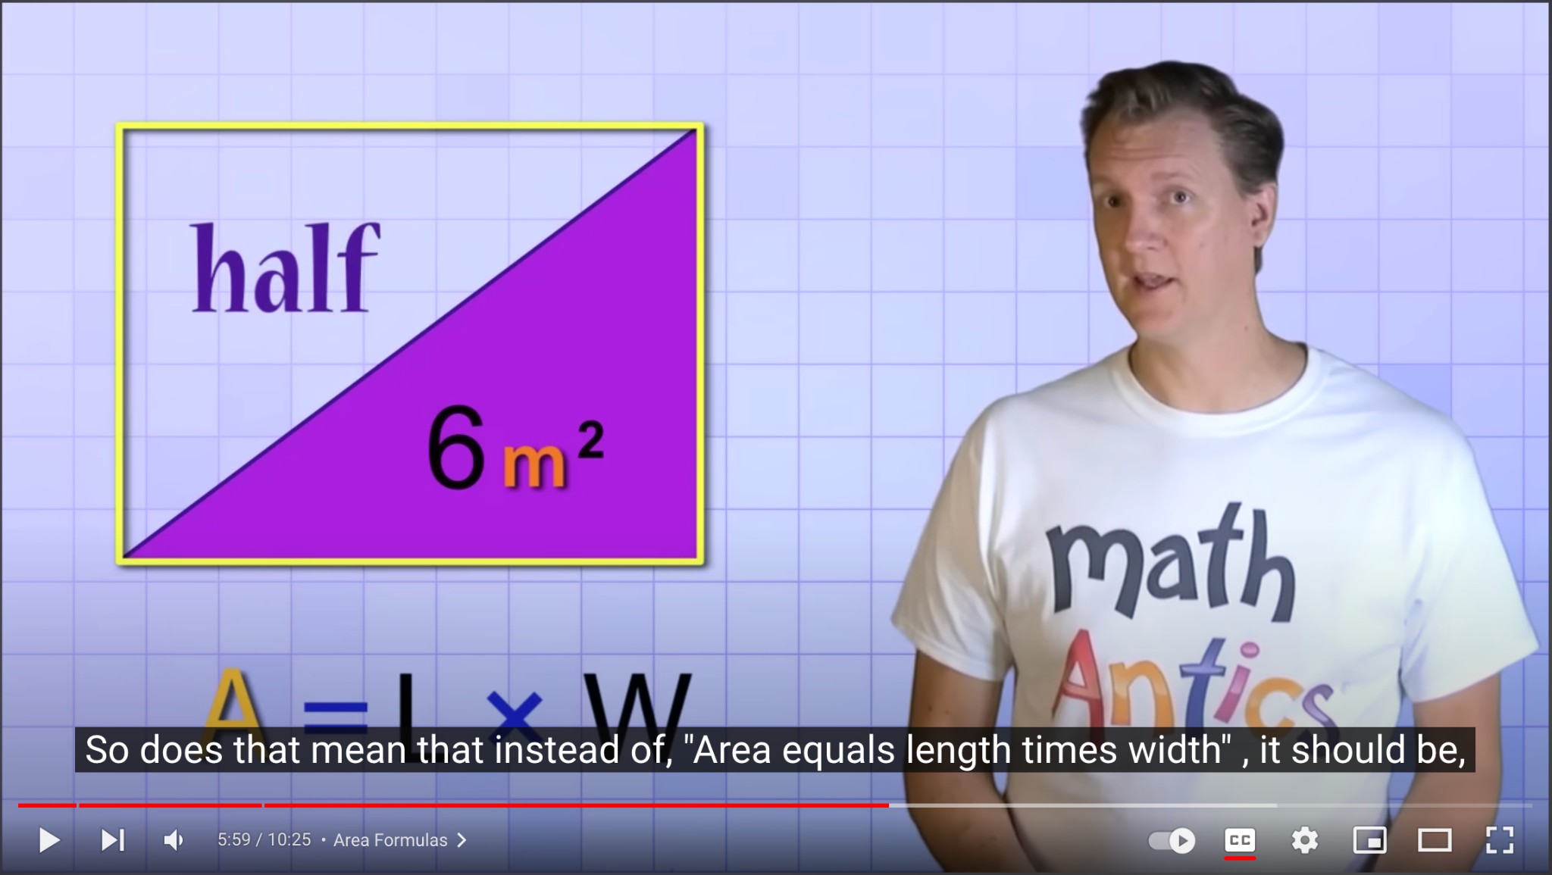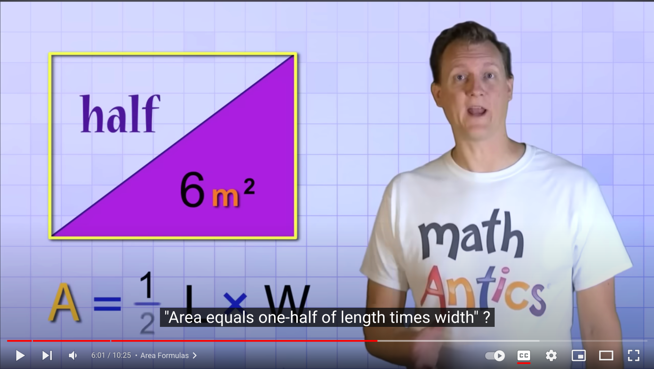

Why did LLM extracted some of the question marked sentences and left others behind?

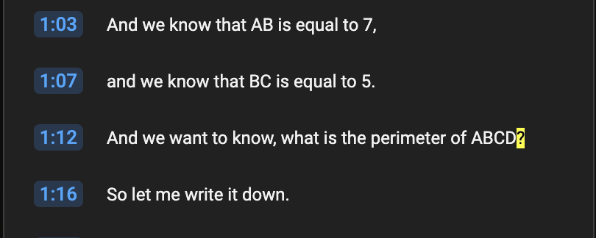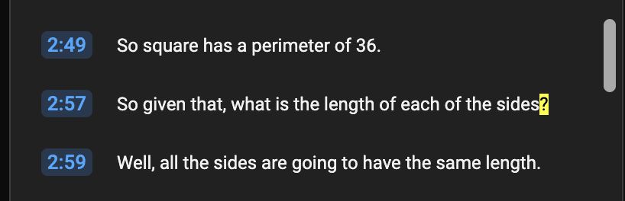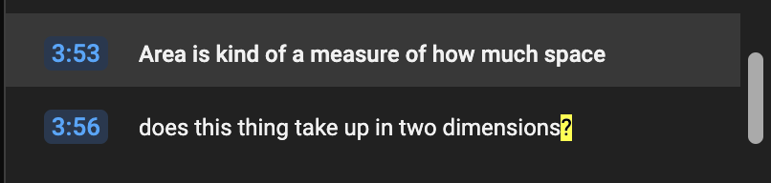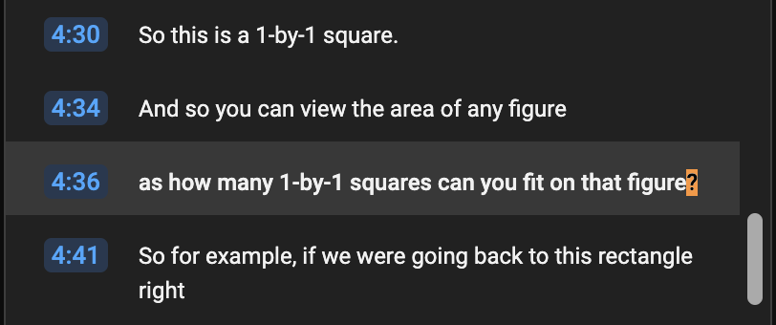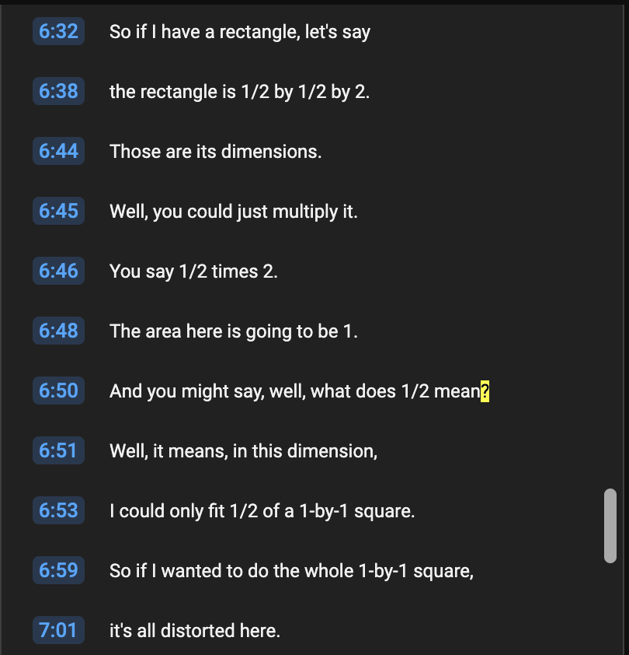

**Word**

| Video Name | Question Topic | Skills Covered | Complete Question | Complete Question Context | Solution | XT | TS |
| --- | --- | --- | --- | --- | --- | --- | --- |
| ["Jessie Solving Word Problems" by ABCmouse.com](https://www.youtube.com/watch?v=s3jP0vnFSxE) | swim trunks | addition | How many beams did the crane deliver? | we had eight steel beams before that last delivery right hank you know it boss and in that last delivery of beams we got oh i didn't get the number of beams that were just dropped in the bin and i need that for my report i only know that we have 19 in total | The crane delivered 11 beams. | Context should extend to 1:51.  The context here seems one part of the procedure in the video.  And it could be longer. | Agree |
| [How To Solve Word Problems of Any Kind . Nutshell maths-2](https://www.youtube.com/watch?v=ON7i6Z1a4no) | word problems | solving linear equations | five years from now the age of jacob will be three times that of his son. five years ago the age of jacob was seven times that of his son. find their present ages. | ... entire video transcript | Jacob's present age is 40 years and his son's present age is 10 years. | Context is more like the calculated procedure | Agree on the question and answer, as a context it extracted the entire video |
| [Solving Word Problems - BrainPOP Jr.](https://www.youtube.com/watch?v=BcXAdGvMefg) | slices of bread | addition | How many slices of bread are needed to make eight sandwiches? | we want to know how many slices of bread are needed to make eight sandwiches | 15 slices | Context should be 1:16-2:30  Wrong answer,  The complete question ends  3:16  Answer should be 16 slices | Question is right, answer and context are incorrect.  The video corrects the number of slices later and the mistake is intentional but LLM failed to detect that. |
| [Solving Word Problems - BrainPOP Jr.](https://www.youtube.com/watch?v=BcXAdGvMefg) | change | subtraction | How much change should I get back if the bread costs $3 and I pay with a $5 bill? | 'I need to know how much change I should get back | 2 dollars | Context 3:34-4:04 | Same as above |

Question not captured

BrainPo

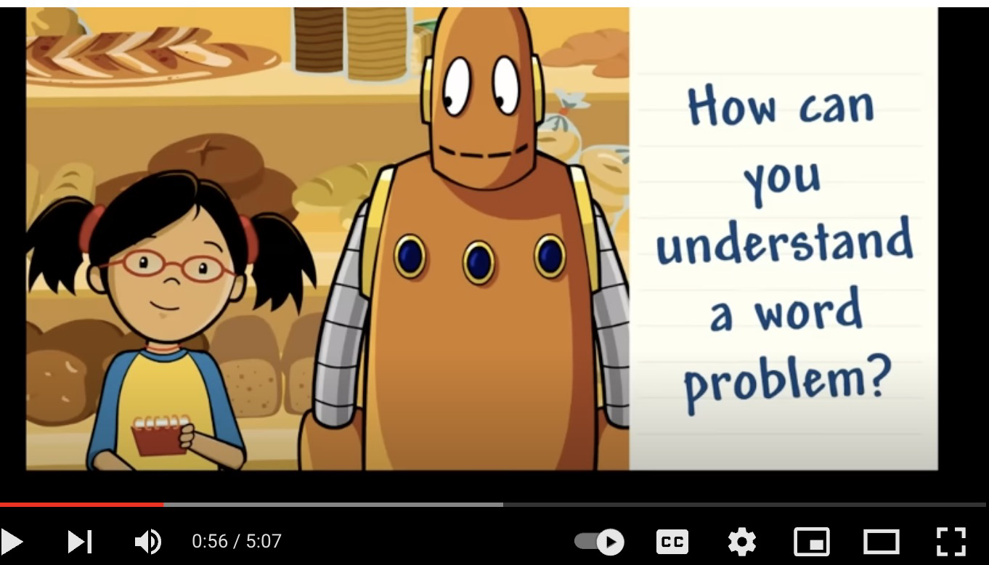

| Video Name | Entertaining off topic content present in the video? (Yes/No) | At what timestamp? | XT | TS |
| --- | --- | --- | --- | --- |
| ["Jessie Solving Word Problems" by ABCmouse.com](https://www.youtube.com/watch?v=s3jP0vnFSxE) | Yes | [{'start time of entertaining content irrelevant to video topic': '0:04', 'end time of entertaining content irrelevant to video topic': '4:16'}] | 0:10 off topic topic about pants color.  Yes | Agree |
| [How To Solve Word Problems of Any Kind . Nutshell maths-2](https://www.youtube.com/watch?v=ON7i6Z1a4no) | No |  | No  Only presentations with text-based representation | Agree |
| [Solving Word Problems - BrainPOP Jr.](https://www.youtube.com/watch?v=BcXAdGvMefg) | Yes | [{'start time of entertaining content irrelevant to video topic': '0:03', 'end time of entertaining content irrelevant to video topic': '0:28'}, {'start time of entertaining content irrelevant to video topic': '4:40', 'end time of entertaining content irrelevant to video topic': '4:53'}] | Yes 0:+ talking to robots about making sandwiches.  4:40- what to make the sandwiches better, and kids talk about raisins and callboards | Agreed.  At 4:40 they talk about what kind of sandwiches Mobie, the robot made.  Additional: At 58 sec it prompts for pausing for reflection, LLM also detected that moment from the video. |

Unit conversion

| Video Name | Question Topic | Skills Covered | Complete Question | Complete Question Context | Solution | XT | TS |
| --- | --- | --- | --- | --- | --- | --- | --- |
| [Shortcut for Metric Unit Conversion](https://www.youtube.com/watch?v=R00HJXPtEGE) | converting between metric units | converting from meters to centimeters, complete question | Convert 6.88 meters to centimeters. | Almost entire video | 688 centimeters | Context ends 1:34.  Answer showed 1:34  New question started, and was missing. | Agree with question and solution not the context |
| [How to Convert mL to moles (Volume to Moles) (Concentration)](https://www.youtube.com/watch?v=pRhf-RMWZgg) | conversion of volume to moles | conversion formula' | How do you convert volume in milliliters into moles? | The answer is with this formula N equals C times V, where C is your concentration and V is your volume. | N = C * V |  | Agree with question and solution not the context |
| [How to Convert mL to moles (Volume to Moles) (Concentration)](https://www.youtube.com/watch?v=pRhf-RMWZgg) | number of moles in given volume | calculation using concentration and volume, complete question | How many moles are in 70 milliliters of 0.124 molar HCl? | The number of moles is the concentration times the volume. The concentration is 0.124 molar or moles per liter. The volume is 70 milliliters. | moles = concentration * volume | I think the context and below two roles should be combined. | agree |
| [How to Convert mL to moles (Volume to Moles) (Concentration)](https://www.youtube.com/watch?v=pRhf-RMWZgg) | conversion of volume to liters | conversion | When you divide 70 milliliters by a thousand, what do you get? | When you divide that by a thousand, you get 0.07 liters. | 0.07 liters | This feels more than a math procedure to conversion? | agree |
| [How to Convert mL to moles (Volume to Moles) (Concentration)](https://www.youtube.com/watch?v=pRhf-RMWZgg) | calculation of moles' | calculation using concentration and volume, complete question | What is the result of 0.124 times 0.07? | When you do that on your calculator, 0.124 times 0.07, you get 0.00868 liters | 0.00868 liters | Context is procedure? | agree |
| [How to Convert mL to moles (Volume to Moles) (Concentration)](https://www.youtube.com/watch?v=pRhf-RMWZgg) | rounding to significant figures | Rounding, complete question | If you want to round this to significant figures, what would be the result? | If you want to round this to significant figures, it would be 0.009 moles. | 0.009 moles | Context: redundant info | disagree |
| [How to Make Metric Conversions for Chemistry : Chemistry and Physics Calculations](https://www.youtube.com/watch?v=V3aG2SH7COI) | metric conversions | making metric conversions | How do you make metric conversions in chemistry? | today I'm here to talk to you about how you make metric conversions for chemistry | Metric conversions in chemistry involve looking at what you're converting from and what you're converting to. The metric system is based on powers of 10, so you can simply move the decimal place to perform the conversion. You also need to know the meanings of different prefixes, such as milli and centi, to determine how many places to move the decimal place. | Redundant info | disagree |

Question missing.

5.53 m to mm (shortcut for MUC) 1:34- 2:03

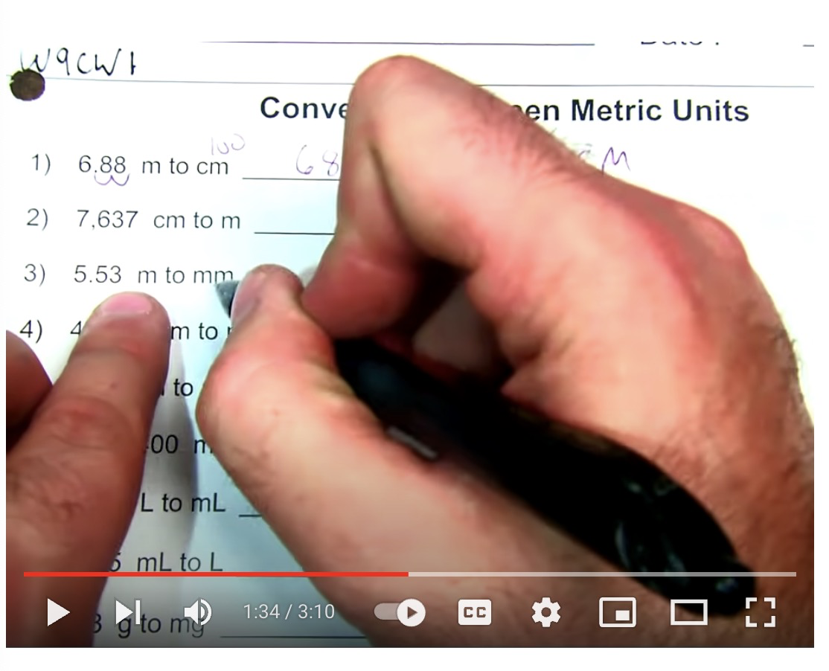

Next question 2:03 - 576 kg to mg

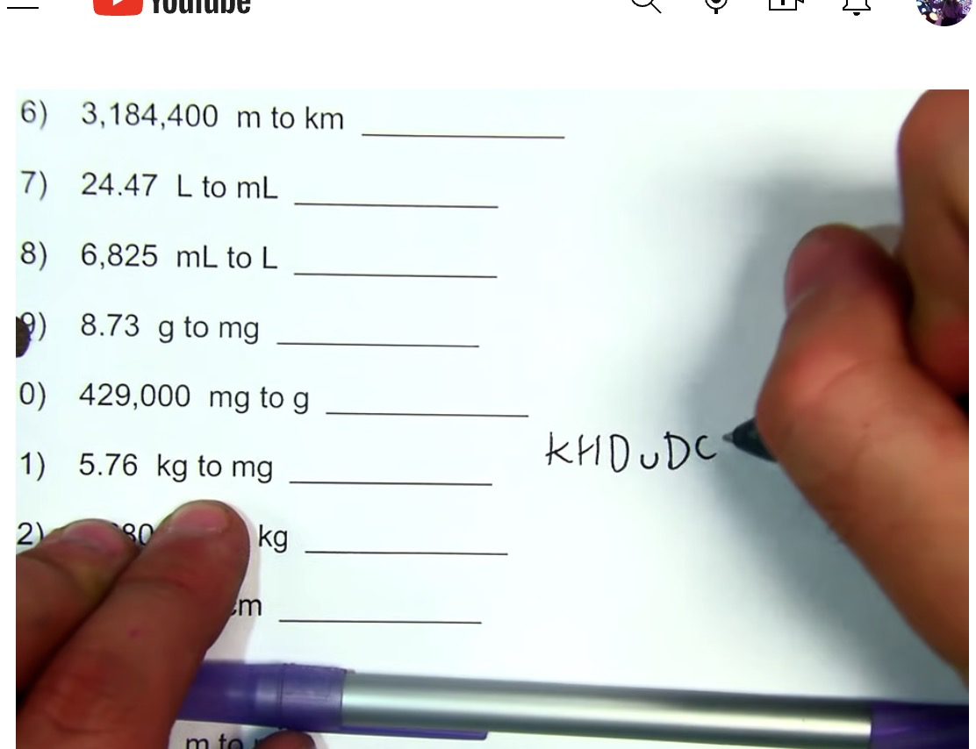

2:43 - question number 13

| Video Name | Entertaining off topic content present in the video? (Yes/No) | At what timestamp? | xt | TS |
| --- | --- | --- | --- | --- |
| [Shortcut for Metric Unit Conversion](https://www.youtube.com/watch?v=R00HJXPtEGE) | Yes | [{'start time of entertaining content irrelevant to video topic': '0:00', 'end time of entertaining content irrelevant to video topic': '0:27'}, {'start time of entertaining content irrelevant to video topic': '0:34', 'end time of entertaining content irrelevant to video topic': '0:48'}, {'start time of entertaining content irrelevant to video topic': '1:02', 'end time of entertaining content irrelevant to video topic': '1:24'}, {'start time of entertaining content irrelevant to video topic': '1:31', 'end time of entertaining content irrelevant to video topic': '1:53'}, {'start time of entertaining content irrelevant to video topic': '1:59', 'end time of entertaining content irrelevant to video topic': '2:24'}, {'start time of entertaining content irrelevant to video topic': '2:40', 'end time of entertaining content irrelevant to video topic': '3:02'}] | No?  1:07 The teacher uses mnemonics to help students remember the measure, it’s definitely a bit off topic, and it’s typical what mnemonic strategies do but personally don’t think it’s entertainment? | No |
| [How to Convert mL to moles (Volume to Moles) (Concentration)](https://www.youtube.com/watch?v=pRhf-RMWZgg) | No |  | No, pure video on solving the question. None of other elements | No |
| [How to Make Metric Conversions for Chemistry : Chemistry and Physics Calculations](https://www.youtube.com/watch?v=V3aG2SH7COI) | No |  | No Teacher + text based representation l | No |

Two-step equation

| Video Name | Question Topic | Skills Covered | Complete Question | Complete Question Context | Solution | XT | TS |
| --- | --- | --- | --- | --- | --- | --- | --- |
| [Method of Elimination Steps to Solve Simultaneous Equations](https://www.youtube.com/watch?v=d6vyYvx8URw) | method of elimination | solving simultaneous equations | What is the aim of the video? | hey guys the aim of this video is his method of elimination to solve the simultaneous equation problem', 'solution to complete question': 'to solve the simultaneous equation problem using the method of elimination | to solve the simultaneous equation problem using the method of elimination | The question is a question but not a learning question? | disagree |
| [Method of Elimination Steps to Solve Simultaneous Equations](https://www.youtube.com/watch?v=d6vyYvx8URw) | method of elimination | solving simultaneous equations | What does the method of elimination do? | what master of elimination does is when you subtract one equation from the other one you end up deleting one variable | when you subtract one equation from the other one, you end up deleting one variable | Context” redundant info. Answer is not an answer? | disagree |
| [Method of Elimination Steps to Solve Simultaneous Equations](https://www.youtube.com/watch?v=d6vyYvx8URw) | method of elimination | solving simultaneous equations | How do you get rid of the Y's in the example? | in this example we will be trying to get rid of the Y's | by making the coefficient in front of the Y the same in both equations | The context is not answering the quesiton? | No example equation was given |
| [Method of Elimination Steps to Solve Simultaneous Equations](https://www.youtube.com/watch?v=d6vyYvx8URw) | method of elimination | solving simultaneous equations | What is the common factor used to make the coefficient in front of the Y the same in both equations? | a common factor with a 6 | 6 | ? | No context |
| [Method of Elimination Steps to Solve Simultaneous Equations](https://www.youtube.com/watch?v=d6vyYvx8URw) | method of elimination | solving simultaneous equations | What is the result of multiplying equation 1 by 3 and equation 2 by 2? | we multiply equation 1 by 3 so that 2y times 3 is 6y and we multiply equation 2 by 2 so that negative 3y turns into 6y | equation 1 becomes 9x + 6y and equation 2 becomes 10x - 6y | correct | No context |
| [Method of Elimination Steps to Solve Simultaneous Equations](https://www.youtube.com/watch?v=d6vyYvx8URw) | method of elimination | solving simultaneous equations | What is the result of adding equation 1 and equation 2? | if we do equation 1 plus equation 2 we end up with 9x + 10x = 19x and 6y + (-6y) = 0y | 19x + 0y = 19x | correct | correct |
| [Method of Elimination Steps to Solve Simultaneous Equations](https://www.youtube.com/watch?v=d6vyYvx8URw) | method of elimination | solving simultaneous equations | What is the result of equation 1 plus 74? | we're left with equation 1 plus 74 | equation 1 plus 74 equals 95' | Correct  (even though I think above questions should be combined as 1 procedure to the math problem). | disagree |
| [Method of Elimination Steps to Solve Simultaneous Equations](https://www.youtube.com/watch?v=d6vyYvx8URw) | method of elimination | solving simultaneous equations | What is the value of x? | we have 19x = 95 | x = 5 | Correct | Correct |
| [Method of Elimination Steps to Solve Simultaneous Equations](https://www.youtube.com/watch?v=d6vyYvx8URw) | method of elimination | solving simultaneous equations | What is the value of y? | we have 2y - 15 = -8 | y = -4 | Correct | Correct |
| [Example: two-step equation with numerator x | Linear equations | Algebra I | Khan Academy](https://www.youtube.com/watch?v=p5e5mf_G3FI) | equation | solving equations, complete question | We have the equation negative 16 is equal to x over 4, plus 2. And we need to solve for x. | Almost entire video | x = -72 | Correct | Correct |
| [Solving Two Step Equations - MathHelp.com - Algebra Help](https://www.youtube.com/watch?v=G6fPIVeS_-A) | equation | solving for X | solve for X in the equation you see here | Almost entire video | x equals 1 | Correct | Correct |

Missing questions:

Method of Elimination: what we can do with equation 2.

S

| Video Name | Entertaining off topic content present in the video? (Yes/No) | At what timestamp? | XT |  |
| --- | --- | --- | --- | --- |
| [Method of Elimination Steps to Solve Simultaneous Equations](https://www.youtube.com/watch?v=d6vyYvx8URw) |  |  | No |  |
| Khan academy |  |  | No |  |
|  |  |  | No |  |